**Finance UAT Notes**

**AR/AP:**

R1- Correcting Arabic "Credit note" translation to: إشعار دائن  
 2- Invoice serial number (S00001) / Credit Serial Number (C00001)  
 3- searchable branch field (in invoice and credit note)  
 4- customer Name should be displayed in Arabic also searchable (Arabic UI)  
 5- in Arabic UI Change the translation of due date field to: تاريخ الاستحقاق

7- add reoccurring invoice feature from e-invoice : once the customer is selected user can select a previous invoice to be copied

6- due date should automatically calculate based on (issue date + sales terms)

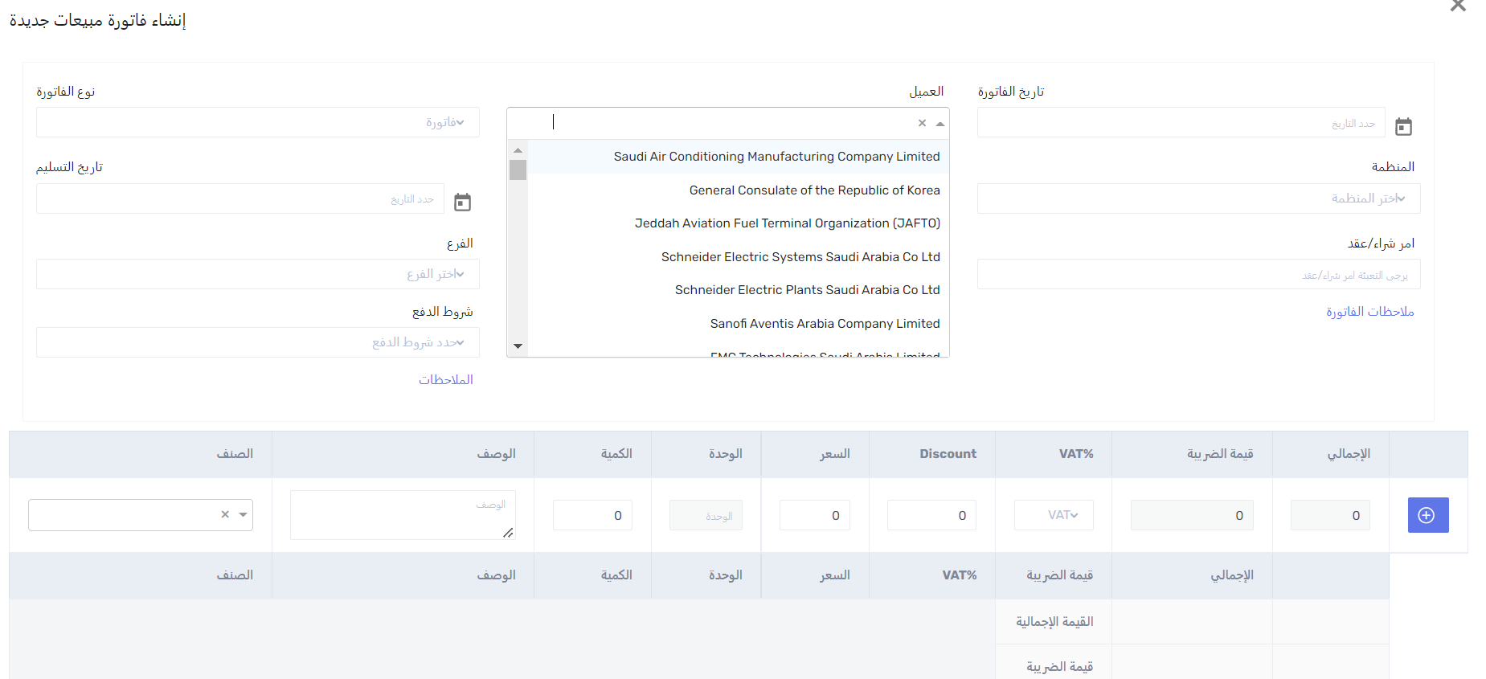

5&6

3

1

4

7

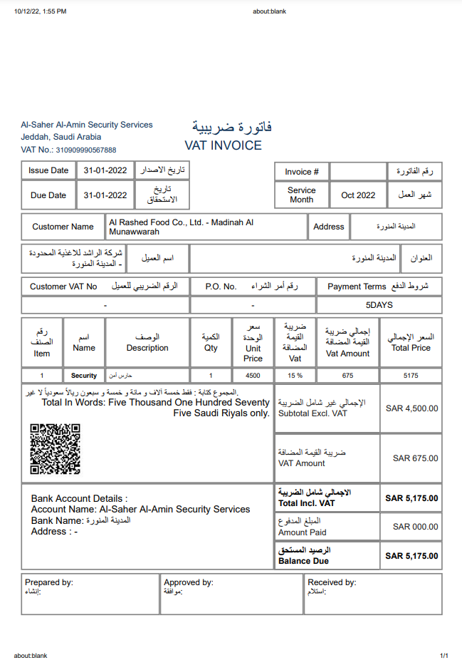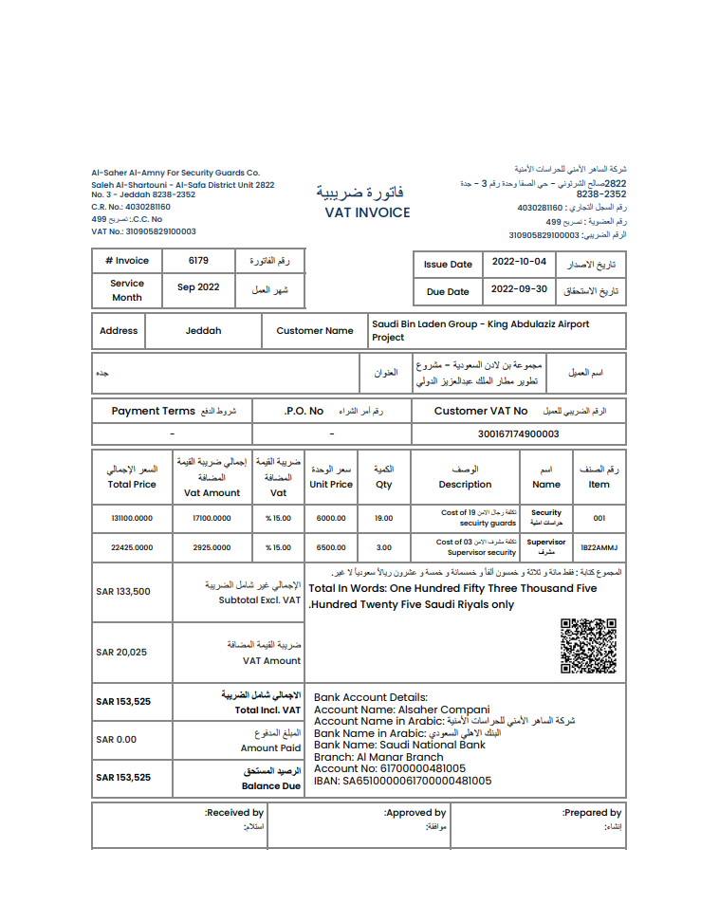**Printing out of invoice:**

Missing

Switch positions

Switch positions

Switch positions

Change to RTL

Switch positions

E-Invoice

ERP

**In Payment module:**

Customers list should come in Arabic in Arabic UI – its only showing english

Narration field is not needed since we have remarks field

Prepared by should come automatically from username

Sales invoice list:

Search for invoice with customer name in Arabic is not working